|  |
| --- |
| **Department of Electrical Engineering** |
| **EE368: Power Electronics** |

|  |  |
| --- | --- |
| **Faculty Member: Dr. Ammar Hassan** | **Dated: ____________________** |
| **Semester: 7th semester** | **Section: Group-2 Power Electronics** |

**Lab07: Hardware – Boost Chopper**

|  |  |  |  |  |
| --- | --- | --- | --- | --- |
| **Name** | **Reg. no.** | **Report Marks / 10** | **Viva Marks / 5** | **Total/15** |
| **Haseeb Ur Rahman** | **287873** |  |  |  |
| **Moaz Ahmad** | **282584** |  |  |  |
| **Misbah Saleem** | **304344** |  |  |  |

The Boost Chopper

**EXERCISE OBJECTIVE**

To learn the operation of a boost chopper.

**DISCUSSION**

**The boost chopper**

As discussed in the previous exercise of this manual, transformers allow ac voltage and current levels to be converted. For example, a step-up transformer is normally used to convert an ac voltage into a higher ac voltage. With dc power, a similar conversion can be performed using a boost chopper. Figure 3-1 shows a boost chopper built with an electronic switch **(Q)** and a diode **(D),** and some waveforms related to this circuit. When electronic switch **Q** switches on, the voltage across its terminals becomes virtually null, the dc power supply voltage **(VI)** is applied to the inductor (L), and the current flowing in inductor L (IL) starts to increase. Simultaneously, diode D switches off since it becomes reverse biased. At this moment, capacitor C starts to discharge into the load and both the output current (IO) and voltage (VO) start to decrease. When electronic switch Q switches off, the voltage across its terminals increases very rapidly until it reaches approximately VO + 0.7 V (due to inductor L). This applies a forward-bias voltage of approximately 0.7 V to diode D, which therefore switches on. At this moment, a current equal to IL ! IO starts to charge up capacitor C, and both VO and IO start to increase. The dc voltage at the boost chopper output (VO) is proportional to the dc voltage at the boost chopper input (VI) and the time the electronic switch is on during each cycle. This time, which is referred to as the on-time (ton), is in turn proportional to the duty cycle α (ton/T) of the switching control signal applied to the gate of electronic switch Q. The equation relating voltages VO and VI is given by the expression:

**VO = VI ÷ (1 - α)**

Thus, voltage VO can be varied by varying the duty cycle α. This equation indicates that voltage VO can range between voltage VI and an infinite voltage when the duty cycle α varies between 0 and 1. In practice, however, the duty cycle α only approaches 0 and 1. Therefore, voltage VO can vary between a voltage a little higher than voltage VI and many times voltage VI. In certain circuits, however, the maximum value of the duty cycle α must be limited to limit the maximum voltage the boost chopper can produce.

Varying the frequency of the switching control signal while maintaining the duty cycle α constant does not vary the dc voltage and current at the boost chopper output (VO and IO). However, the ripple on the output voltage decreases as the frequency of the switching control signal increases.

The power which the boost chopper delivers at its output (PO) is equal to the power it receives at its input (PI) minus the power dissipated in the semiconductor switch and the inductor. The power dissipated in the semiconductor switch and the inductor is usually small compared to the power PO. The power efficiency of boost choppers, thus, often exceeds 80%. Notice that the power efficiency is the ratio of the output power on the input power times 100%, as stated in the following equation:

**Power Efficiency = (PO ÷ PI) × 100%**

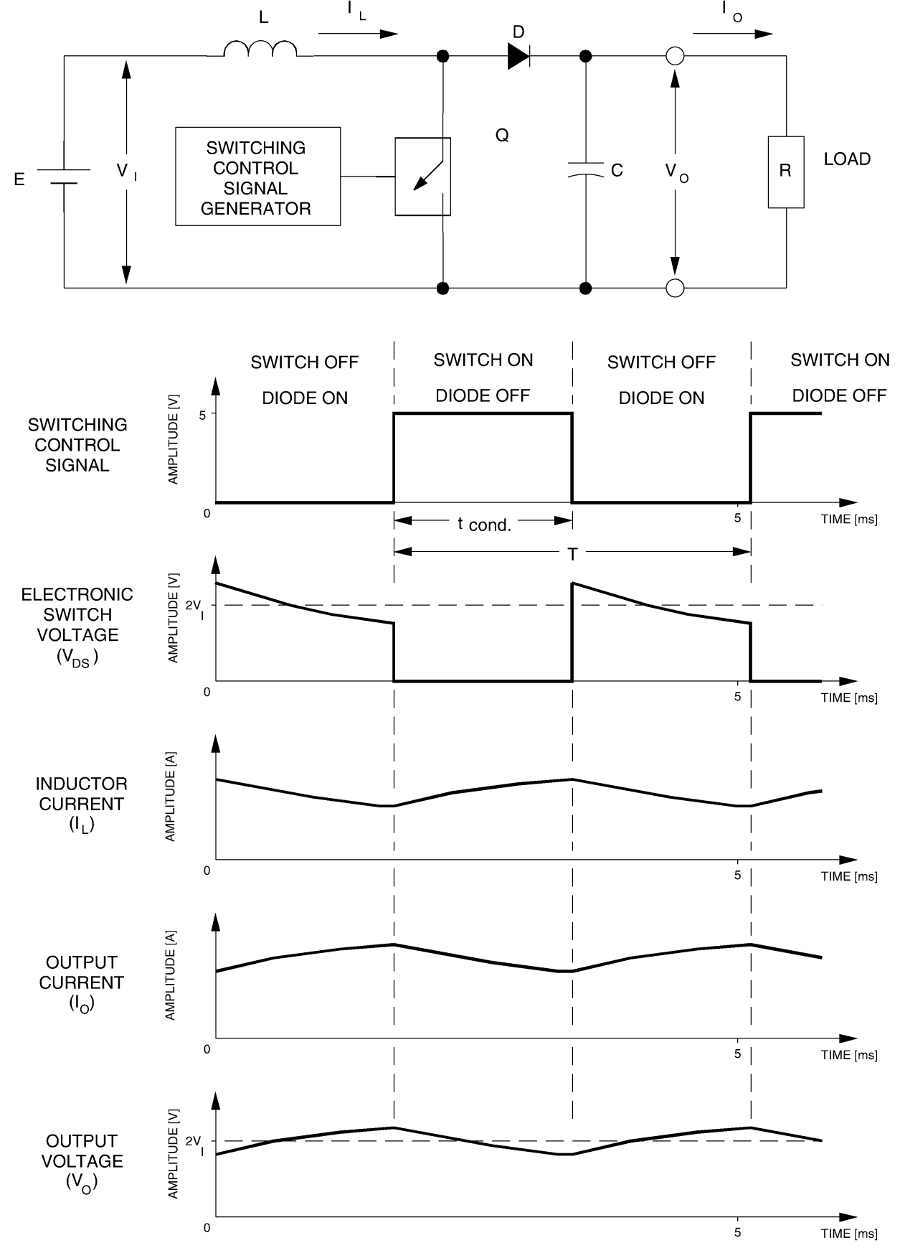

**Figure 1. Operation of a boost chopper.**

**Procedure summary**

In the first part of this exercise, you will set up in the Mobile Workstation the equipment required to carry out this exercise.

In the second part of this exercise, you will use the circuit shown in Figures 3-2 and 3-4 to observe the operation of a boost chopper. The only difference in these figures is the location of the dc voltmeter. In this circuit, the boost chopper output is connected to a resistive load consisting of resistors R1 and R2 connected in series. A voltage isolator and a current isolator will allow you to observe the waveform of the voltage at the boost chopper output and the waveform of the current at the boost chopper input.

You will vary the duty cycle of the switching control signal while observing the dc voltage and current at the boost chopper output. This will allow you to verify the relationship between the duty cycle and the dc voltage at the boost chopper input and output, and to determine the direction of power flow.

In the third part of this exercise, you will vary the frequency of the switching control signal while observing the dc voltage and current, as well as the voltage waveform, at the boost chopper output. This will allow you to verify the effect of frequency on these parameters. In the fourth part of this exercise, you will determine the power at the input and output of the boost chopper. You will then compare the output power to the input power and determine the power efficiency of the chopper.

In the fourth part of this exercise, you will determine the power at the input and output of the boost chopper. You will then compare the output power to the input power and determine the power efficiency of the chopper.

**EQUIPMENT REQUIRED**

|  |  |
| --- | --- |
| **MODEL** | **DESCRIPTION** |
| 8311 | Resistive Load |
| 8325 | Smoothing Inductors |
| 8412-1X | DC Voltmeter/Ammeter |
| 8837 | MOSFET Chopper / Inverter |
| 8837-AX | IGBT Chopper / Inverter |
| 9029 | Chopper / Inverter Control Unit |

**PROCEDURE**

**CAUTION!**

**High voltages are present in this laboratory exercise! Do not make**

**or modify any banana jack connections with the power on unless**

**Otherwise specified!**

**Setting up the equipment**

* 1. Install the Power Supply, the Enclosure / Power Supply, the Chopper/Inverter, the Smoothing Inductors, the DC Voltmeter/Ammeter, and the Resistive Load modules in the Mobile Workstation.
* 2 Install the Chopper / Inverter Control Unit and the Current/Voltage Isolators in the Enclosure/Power Supply.
* 3. Make sure that the main power switch of the Power Supply is set to the O (OFF) position. Connect the Power Supply to a three-phase wall receptacle.
* 4. Plug the Enclosure / Power Supply line cord into a wall receptacle. Set the rocker switch of the Enclosure / Power Supply to the I (ON) position.
* 5. On the Power Supply, set the 24-V ac power switch to the I (ON) position.
* 6. Make sure that the toggle switches on the Resistive Load module are all set to the O (open) position.

**Operation of the boost chopper**

* 7. Connect the modules as shown in Figure 2.

**Note:** *Diode D1 is the power diode connected in parallel with*

*electronic switch Q1. Diode D4, which is connected in parallel with*

*electronic switch Q4, and electronic switch Q1 are not shown in*

*Figure 3-2 because they are not used in this circuit. Electronic*

*switch Q1 is forced to the off state by connecting SWITCHING*

*CONTROL INPUT 1 of the Chopper / Inverter module to the common point.*

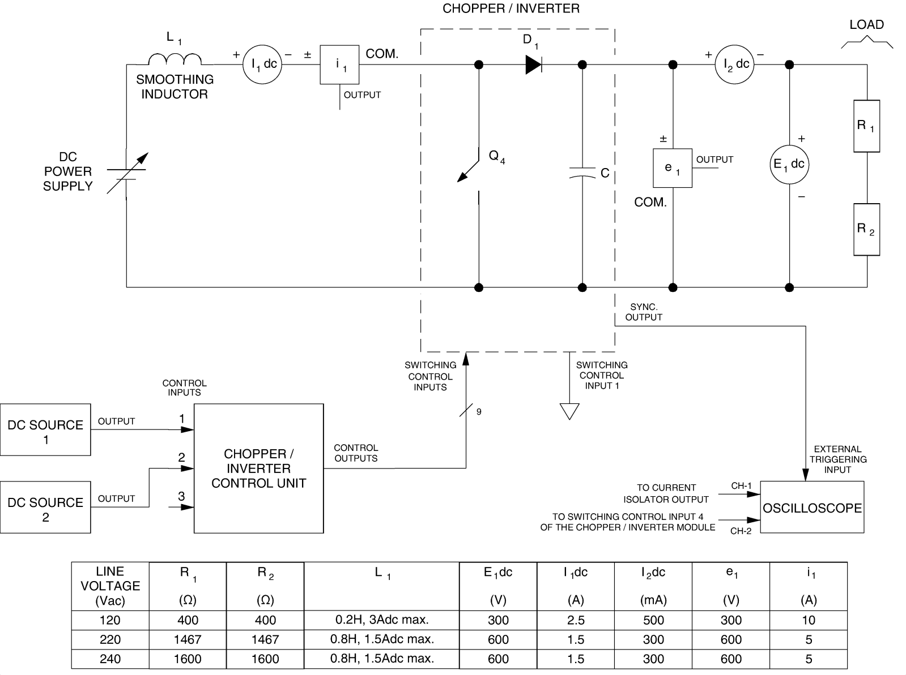

**Figure 2. Circuit used to observe the operation of the boost chopper.**

* 8. Make the following settings:

**On the Power Supply**

Voltage Selector . . . . . . . . . . . . . . . . . . . . . . . . . . . . . . . . . . . . . . . . . . . . . . . . . . . . . . 7-N

**On the Chopper / Inverter Control Unit**

DC SOURCE 1 . . . . . . . . . . . . . . . . . . . . . . . . . . . . . . . . . . . . . . . . . . . . . . . . . . . MAXimum

DC SOURCE 2 . . . . . . . . . . . . . . . . . . . . . . . . . . . . . . . . . . . . . . . . . . .. . . . . . . mid position

MODE . . . . . . . . . . . . . . . . . . . . . . . . . . . . . . . . . . . . . . . . . . . . . . . . . . . . . . . . CHOP. PWM

**On the Chopper / Inverter module**

Interconnection Switch S1 . . . . . . . . . . . . . . . . . . . . . . . . . . . . . . . . . . . . . . . . . . . . . . O

**On the Oscilloscope**

Channel-1 Sensitivity . . . . . . . . . . . . . . . . . . . . . . . . . . . . . . . . . . 1 V/DIV. (DC coupled)

Channel-2 Sensitivity . . . . . . . . . . . . . . . . . . . . . . . . . . . . . . . . . . 2 V/DIV. (DC coupled)

Vertical Mode . . . . . . . . . . . . . . . . . . . . . . . . . . . . . . . . . . . . . . . . CHOPped

Time Base . . . . . . . . . . . . . . . . . . . . . . . . . . . . . . . . . . . . . . . . . . . 1 ms/DIV.

Trigger Source . . . . . . . . . . . . . . . . . . . . . . . . . . . . . . . . . . . . . . . EXTernal

Trigger Slope . . . . . . . . . . . . . . . . . . . . . . . . . . . . . . . . . . . . . . . . positive (+)

Trigger Coupling . . . . . . . . . . . . . . . . . . . . . . . . . . . . . . . . . . . AC

**D = 0.75**

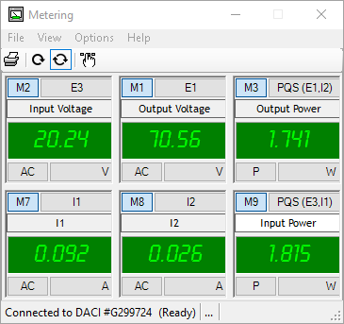

**D = 0.5**

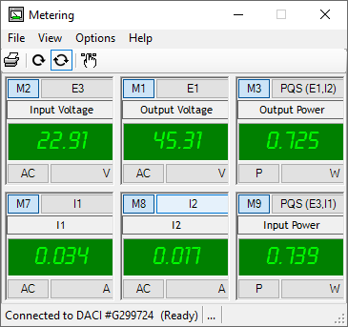

**D = 0**

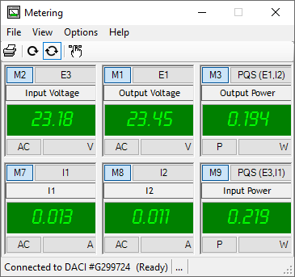

* 9. On the Power Supply, make sure that the voltage control knob is set to the 0 position then set the main power switch to the I (ON) position.

Slowly set the voltage control knob of the Power Supply to the 20 position (20% of the ac network line voltage). This supplies dc power to the buck chopper.

On the oscilloscope, make the appropriate settings to position the traces of channels 1 and 2 in the upper and lower halves of the screen, respectively. The traces of channels 1 and 2 represent the waveform of the current flowing in inductor L1 and the switching control signal applied to electronic switch Q4, respectively.

On the Chopper / Inverter Control Unit, set the DC SOURCE 2 control knob so that two complete cycles of the switching control signal coincides as closely as possible with the full width of the oscilloscope screen (usually ten 1-cm divisions). This sets the period of the switching control signal to approximately 5 ms. Consequently, the operating frequency of the boost chopper is approximately 200 Hz.

* On the Chopper / Inverter Control Unit, slowly set the DC SOURCE 1 control knob so that the duty cycle of the switching control signal is equal to approximately 90% while observing the voltage indicated by the DC Voltmeter/Ammeter.

Describe how the dc voltage at the boost chopper output varies when the duty cycle of the switching control signal is increased.

**

For boost converter the derived output equation states:

Vo= $\frac{Vi}{1-D}$

Where MD is the voltage conversion ratio which is basically the ratio of output voltage over input voltage given as follows:

MD=

Changing the duty cycle (D) will change the output of circuit. The higher the duty cycle the higher the output voltage because the transfer of energy occurs from the Source to the Inductor during the first portion of a duty cycle and then Energy is transferred from the Inductor to the output during the second portion of the duty cycle. And as the duty cycle increases, the energy increases the more than two times the applied voltage.

Sketch the waveforms displayed on the oscilloscope screen

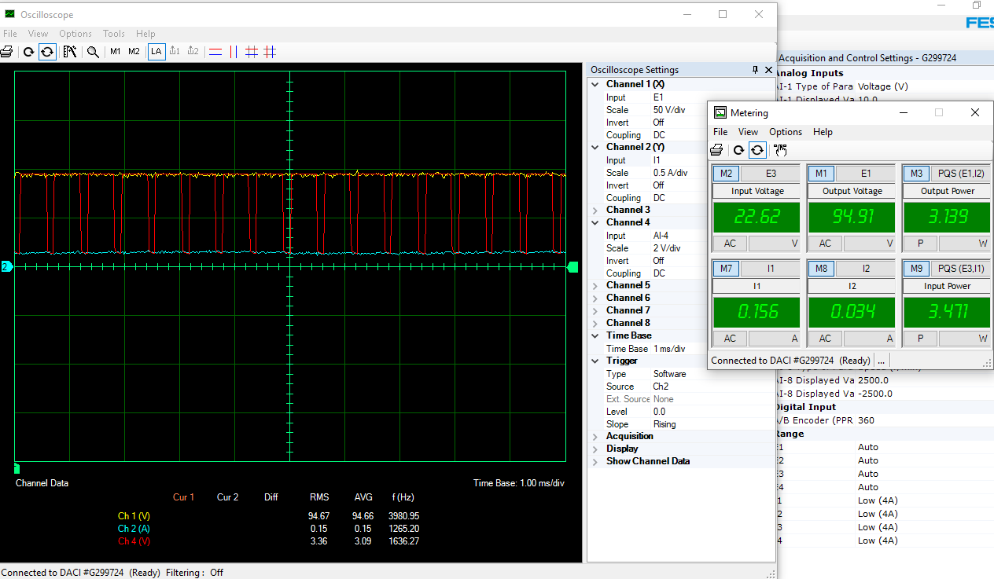

From the waveforms sketched, briefly explain why the boost chopper can produce output voltages which are much higher than the voltage applied at its input.

**Answer:**

**As the conversion ratio M(D) of circuit increases in the value so does the boosting action of the circuit increases. At higher duty cycle, capacitor does not fully discharge during off time of the cycle which helps in increases the overall energy of the circuit that eventually increases the output voltage of circuit by decreasing the current level.**

* On the Chopper / Inverter Control Unit, set the DC SOURCE 1 control knob back to the MAX. position to set the duty cycle of the switching control signal to minimum.

On the DC Voltmeter/Ammeter, measure and note the dc voltage at the output of the boost chopper.

On the Power Supply, measure and note the dc voltage provided to the boost chopper by the variable voltage dc power supply.

Explain why this circuit is referred to as a boost chopper, knowing that the duty cycle of the switching control signal is set to minimum.

**Answer:**

**According to the derived output equation:**

**Vo= $\frac{Vi}{1-D}$**

**It obvious that if we kept the switching control to its minimum value, the output voltage will not lower its value below than the input voltage. AT D=0,**

**Vo = VI**

* On the Chopper / Inverter Control Unit, slowly set the DC SOURCE 1 control knob so that the duty cycle of the switching control signal is equal to approximately 90%, while observing the current indicated by the centre meter (I2dc) on the DC Voltmeter/Ammeter.

Does the polarity of the dc current flowing in the load change as the duty

Yes No

In which direction does the power flow?

**Answer:**

**Power flows from the source to load due the positive polarities of both current and voltage waves across the load sides.**

* On the Power Supply, set the voltage control knob to the 0 position then set the main power switch to the O position.

Modify the connections so that the modules are connected as shown in Figure 3-4. In this figure, the voltmeter of the DC Voltmeter/Ammeter is connected at the input of the boost chopper instead of being connected to its output, and channel 1 of the oscilloscope is connected to the voltage isolator OUTPUT instead of being connected to the current isolator OUTPUT.

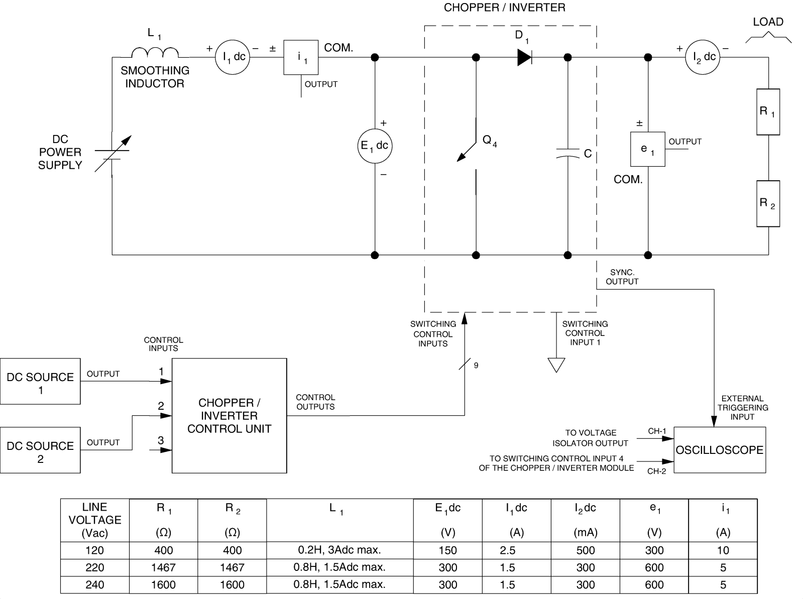

Make the following settings on the oscilloscope:

Channel-1 Sensitivity . . . . . . . . . . . . . . . . . . . 2 V/DIV. (DC coupled)

Time Base . . . . . . . . . . . . . . . . . . . . . . . . . . . . . . . . . . . . 0.2 ms/DIV.

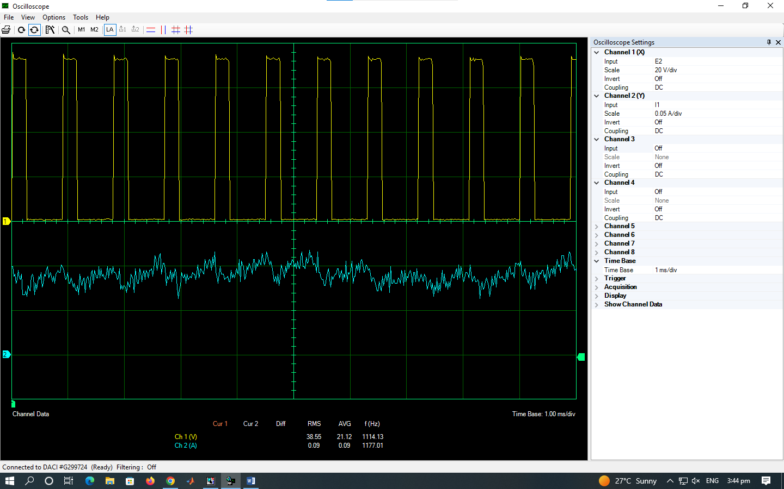

**D=0.435**

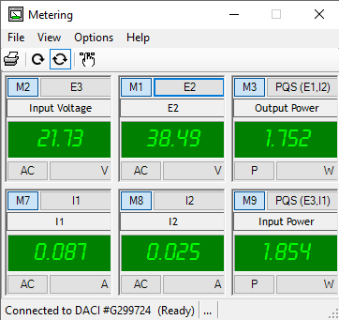

* On the Chopper / Inverter Control Unit, set the DC SOURCE 2 control knob so that a complete cycle of the switching control signal coincides as closely as possible with the full width of the oscilloscope screen (usually ten 1-cm divisions). This sets the period of the switching control signal to approximately 2 ms. Consequently, the operating frequency of the boost chopper is approximately 500 Hz.

On the Chopper / Inverter Control Unit, set the DC SOURCE 1 control knob so that the duty cycle of the switching control signal is equal to 80%.

* On the Power Supply, set the main power switch to the I (ON) position, then slowly set the voltage control knob of the Power Supply to the 20 position.

Measure and record the dc voltage at the boost chopper input (VI). It is indicated by the DC Voltmeter/Ammeter.

**VI =21.73 V dc**

Calculate the dc voltage which should appear at the output of the boost chopper using the following equation:

**VO = VI ÷ (1-α)**

**Vo= $\frac{21.73}{1-0.4}$**

**VO =36.21 V dc**

Determine the dc voltage at the boost chopper output using the output signal of the voltage isolator which is displayed on the oscilloscope screen.

**VO (measured) =38.49 V dc**

Measured and calculated voltage are almost close, the difference is caused by the manual changing of control knob MOSFET which is measured at **duty cycle of 0.435.**

**For value of D = 0.435:**

**VO (calculated) =38.49 V dc**

**For value of D = 0.4:**

**VO (measured) =36.21 V dc**

Does the measured output voltage correspond to the calculated output voltage?

Yes No

**Observing the effect of the switching control signal frequency**

* Make the following settings on the oscilloscope:

Time Base . . . . . . . . . . . . . . . . . . . . . . . . . . . . . . . . . . . . . . 2 ms/DIV.

On the Resistive Load module, modify the setting of the toggle switches so that resistors R1 and R2 have the following resistance value:

|  |  |
| --- | --- |
| **R1** | **R2** |
| **Ω** | **Ω** |
| 629 | 629 |

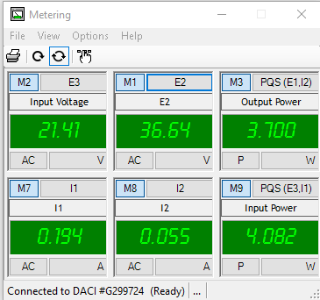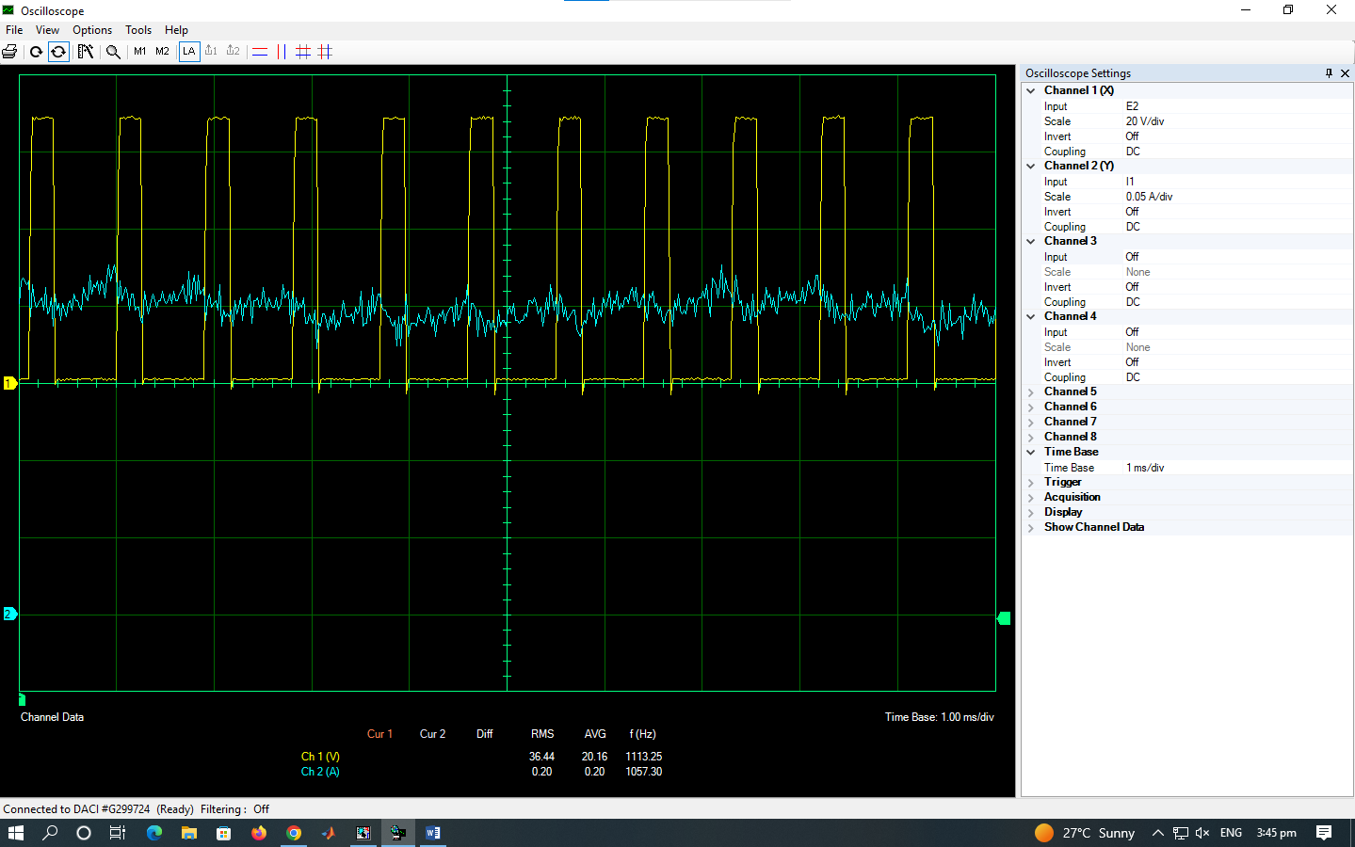On the Chopper / Inverter Control Unit, slowly turn the DC SOURCE 2 control knob in both directions to vary the frequency of the switching control signal, while observing the dc voltage and current at the boost chopper output on the oscilloscope screen and on the DC Voltmeter/Ammeter, respectively.

Does the frequency of the switching control signal have a significant effect on the dc voltage and current the boost chopper provides? If so, describe this effect.

**Answer:**

**Changing the frequency has no effect on the output DC voltages and currents. However, reduction of the ripples present at output voltage occurs by increasing the frequency.**

**Output power versus input power**

* On the Chopper / Inverter Control Unit, set the DC SOURCE 2 control knob to the MAX. position.

On the voltmeter of the Power Supply, measure and note the dc voltage which the variable-voltage dc power supply supplies to the boost chopper.

On DC Voltmeter/Ammeter, measure and note the dc current which the variable-voltage dc power supply supplies to the boost chopper.

Use these results to calculate the power which is supplied to the buck chopper (PI). Record the resulting power in the space below.

**PI =4.08 W**

* On the DC Voltmeter/Ammeter, measure and note the dc current which the buck chopper supplies to the load.

Determine the dc voltage which the boost chopper supplies to the load using the voltage waveform displayed on the oscilloscope screen.

Use these results to calculate the power which is supplied to the load (PO). Record the resulting power in the space below.

**PO =3.7 W**

Calculate the power efficiency of the boost chopper using the following equation:

**Power Efficiency = (PO ÷ PI) × 100%**

**Power Efficiency =90.68%**

Is the power at the output of the boost chopper nearly equal to the power at its input?

Yes No

* On the Power Supply, set the voltage control knob to the 0 position then set the main power switch and the 24-V ac power switch to the O position. Set the rocker switch on the Enclosure / Power Supply to the O position. Remove all leads, cables, and probes.

**Conclusion:**

In this lab, we observe the current and voltage characteristics of Boost converter. We briefly studied the effect of switching characteristics of MOSFET and behavior of boost converter by the change of duty cycle over its output voltage.

Some of the key points of this lab are given below:

* Ignoring hardware constraint, input and ouput power of circuit remains equal.
* Changing frequency does not affect the characteristics of voltage and current at load side rather it improves the ripples efficiently.
* Efficiency of boost converter was found close to 90 % which indicate a very good efficiency with low power losses.